
PROJECT 4
Project Proposal
Term 2 Assignment

Group Number: 7

Group Name: The Legendaries

Members:
No. | Surname, Initial | Student Number
1 | Kabai Moipone | 2 | 1 | 5 | 2 | 0 | 3 | 5 | 6 | 9
2 | Mkalali Siphelele | 2 | 2 | 0 | 0 | 4 | 2 | 9 | 2 | 6
3 | Msomi Sebe | 2 | 1 | 6 | 0 | 2 | 8 | 6 | 0 | 4
4 | Ncubukezi Bongeka | 2 | 1 | 5 | 1 | 8 | 0 | 9 | 2 | 5
5 | Tshizana Busiswa | 2 | 0 | 9 | 0 | 5 | 7 | 1 | 8 | 1

Due Date: 22 July 2020
Table of Contents

Introduction 3
Background and Statement Problem 4
How does social media contribute to the rise of fake news? 4
Why are we doing this project? 4
Detailing 5

Introduction
Many people now get news from social media sites and network of which it can be difficult to tell whether stories are credible or not especially when fake news gets more attention than real news. Social media is an interactive computer-mediated technology that facilitates the creation and sharing of information, ideas, career interests and other forms of expression via virtual communities and networks. Daily or at least most of the time we use social media to acquire information. Examples of social media platforms include. Facebook, YouTube, Twitter, LinkedIn, Instagram and many more
In the process of using these social media platforms, we often lose focus on why we chose to use them in the first place. This is usually caused by the need for popularity which influences so many things, like the content shared amongst these platforms. Sensibly, people use social media to network and stay in touch with others, to stay updated with news and current events, for entertainment and many more. It is very interesting how most of the top reasons are all linked to what we call ‘passive networking’ – that means users who come to social media to consume content rather than actively contributing to the stories. Most of the information consumed from the media is secondary, meaning that it is not the true version of the story, or at least what we believe to be factual.
Our aim is to try decrease this terrific rise of these deceptive news by developing a mobile application that will be user-friendly and not require any kind of training before the end-user could interact with it. Our application will have a search box where any title of an article, blog, or journal could be typed in for searching the probability of that information being true. For example, if a user types ‘Drug use in Cape Town and the author name’ and enters search, it should retrieve the article title, next to it the probability of it being false all in bold.

Background and Problem Statement
How does social media contribute to the rise of fake news?
We have come to the realization realized that fake news is excessively growing on social media platforms. Our aim is to thoroughly research this concept while outlining how these news are spread out and why so that we could try decrease this terrific rise of these deceptive news by developing a mobile application that will be user-friendly and not require any kind of training before the end-user could interact with it. The most obvious reasons for the spread of false news is that everyone feels entitled to sharing their opinions, being their own version of the story and that no one ever face legal actions for deformation.
Social media has allowed people the ability to exchange information at a much greater pace, to a far wider audience than ever before. However, this information is not always truthful. (Companies fear rise of fake news and social media rumours, 2020) states that fake news and false market rumours spread by social media are becoming an increasing headache for companies around the world, fresh data reveal. The deliberate making up of news stories to fool or entertain is nothing new. But the arrival of social media has meant real and fictional stories are now presented in such a similar way that it can sometimes be difficult to tell the two apart.
Why are we doing this project?
Fake news causes confusion about current issues and events, but it continues to be circulated. Based on the research topic, it is important for us to research how people encounter the spread of fake news with regards to Covid-19. This will help us in implementing a solution to limit the amount of false information spread on the media since most people do what is called ‘passive networking’ – that means users who come to social media to consume content rather than actively contributing to the stories. This will also help people to have the real information about matters around them. Because we live in a technology based world, everything travels quickly and fast in the social media platforms.
2.5 The importance of fake news can also be judged through below diagram shows dramatically fake news gained worldwide popularity in 2016. The diagram below shows the rapid spread of fake news through social media.

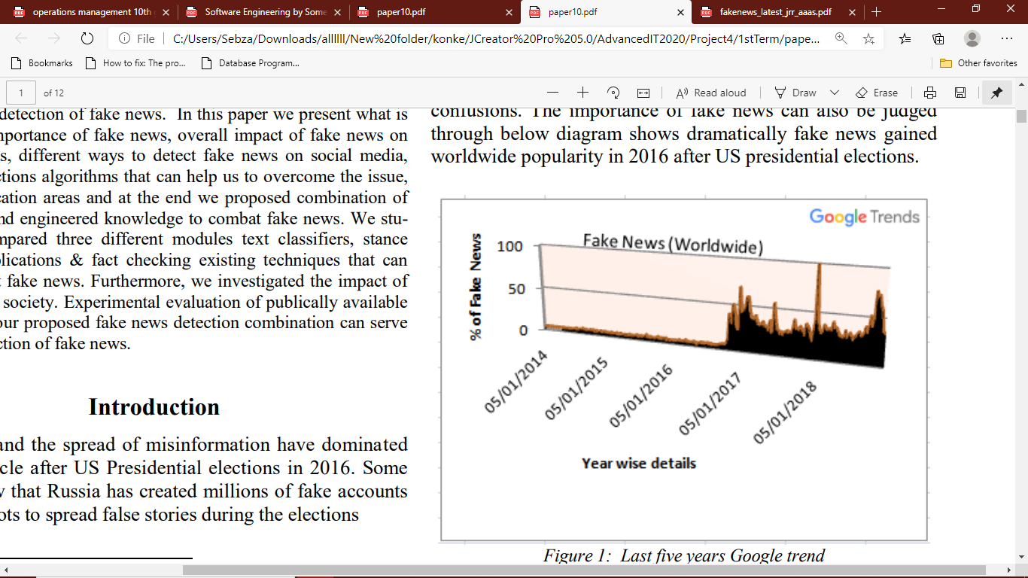
Fake news changes the way people interpret and respond to real news. For example, some fake news was just created to trigger people’s distrust and make them confused, impeding their abilities to differentiate what is true and what is not true (Scott et al., 2000; Leonhard et al., 2017; Himma 2017). It is important to understand that fake and deceptive news have existed for a long time. It‟s been part of the conversation as far as the birth of the free press (Soll 2016).
Detailing

